HEPSİBURADA AUTOMATION CASE MANUAL

After importing HepsiburadaAutomationCase.zip to Eclipse, it is run as TestNG Test. File Hierarchy is as in the Picture below. If test fails , screeshots are captured and stores under ScreenShots folder.

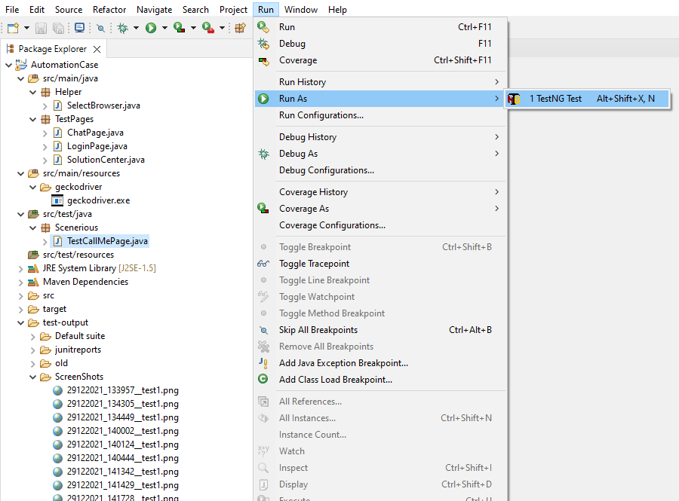

You can choose the browser via Messagebox

